Name:_______________________________________

Assignment 5: Graphing Puzzle

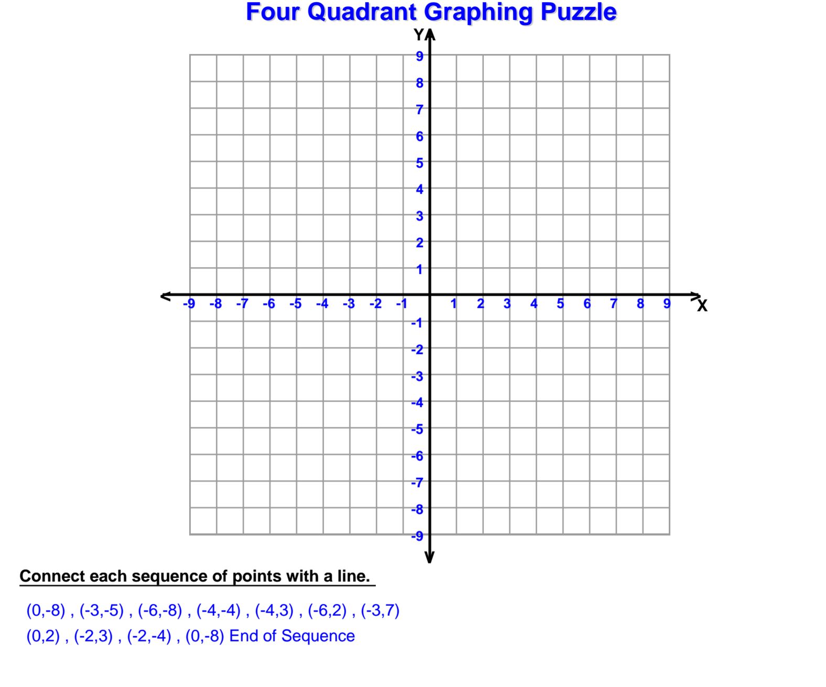

What is the shape?__________________________________